**ST STEPHEN’S AND QUEEN VICTORIA**

**SCHOOLS TRUST BOARD**

**ANNUAL REPORT**

**For the year ended 30 September 2019**

**THE ST STEPHEN’S AND QUEEN VICTORIA**

**SCHOOLS TRUST BOARD**

**ANNUAL REPORT**

**FOR THE FINANCIAL YEAR ENDED 30 SEPTEMBER 2019**

*Trust Purpose*

*"The advancement and propagation of education for children in New Zealand, principally for girls and boys of New Zealand Maori descent but including peoples of all races and denominations, principally through the provision and management of schools and the provision and continuing development of an integrated curriculum which features foundation teaching, learning skills and excellence and blends elements of Maori concepts and Christian values with the New Zealand education curriculum"*

**SUMMARY**

Trustees are pleased to present this report on the activities and financial performance of the St Stephen’s and Queen Victoria Schools Trust Board for the year ended 30 September 2019.

During 2019 Trustees continued to explore ways in which it can best achieve its stated strategic purpose, being:

* continuing to build and manage a sustainable endowment fund to ensure the strategies of the Trust can be achieved,
* to continue to offer scholarships, and
* investigate the means to establish a kura(s)

Trustees continues to manage the Trust’s assets in a conservative manner to grow the Trust’s endowment while it also continues to investigate the best long term use of the Trust’s Bombay and Parnell as part of finalising its long term strategic plan.

At the same time, during 2019 the Trust continued provide scholarships in accordance with its charitable purpose, awarding $157,000 of scholarships to thirty one recipients for study in 2020. The Trust looks forward to continuing to offer these scholarships for the benefit rangatahi, and their whanau, throughout Aotearoa.

The Trust also commissioned research in respect to the characteristics of education in the modern world and, on the basis of this research, is now undertaking further investigations and consultations as to the potential to establish a new kura in the coming years.

**FINANCIAL PERFORMANCE**

As Trustees have previously reported, the Trust has transformed itself over the last decade from a position of incurring significant annual operating deficits and having debt owing to third parties, to generating positive returns that allow the Trust to achieve its purpose.

As a consequence of the investment strategy has been implemented over recent years, the capital of the Trust has grown to $83 million as at 30 September 2019. Additionally the Trust has strong cash flow and no debt.

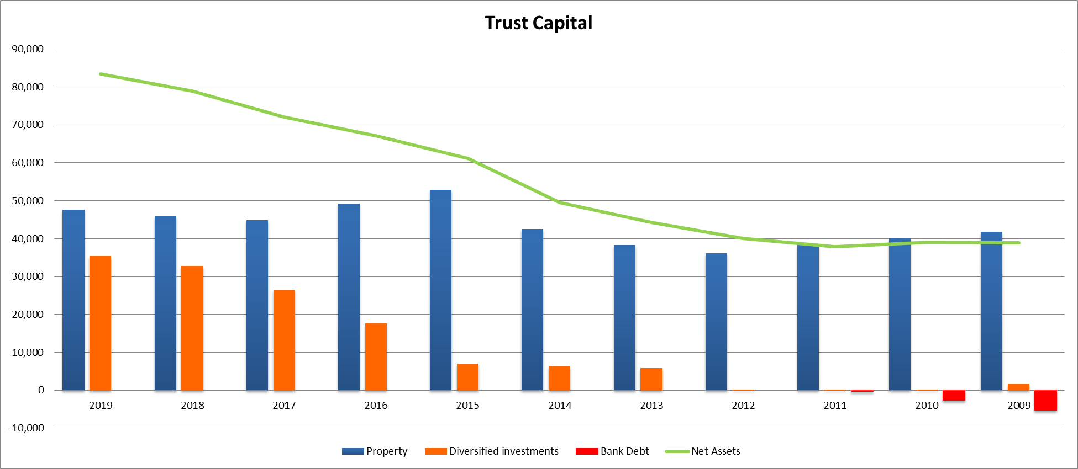

The financial performance of the Trust for the five years ended 30 September 2019 can be summarised as follows:

|  |  |  |  |  |  |  |  |  |  |  |  |
| --- | --- | --- | --- | --- | --- | --- | --- | --- | --- | --- | --- |
|  | **2019**  **$’000** |  | **2018**  **$’000** |  | **2017**  **$’000** |  | **2016**  **$’000** |  | **2015**  **$’000** |  |  |
|  |  |  |  |  |  |  |  |  |  |  |  |
| Revenue | 2,275 |  | 1,985 |  | 1,850 |  | 1,671 |  | 1,793 |  |  |
| Expenditure | 682 |  | 663 |  | 644 |  | 890 |  | 656 |  |  |
| Operating surplus | 1,593 |  | 1,322 |  | 1,206 |  | 781 |  | 1,137 |  |  |
|  |  |  |  |  |  |  |  |  |  |  |  |
| Net revaluation and realisation of investments | 3,033 |  | 5,712 |  | 3,818 |  | 5,209 |  | 10,567 |  |  |
|  |  |  |  |  |  |  |  |  |  |  |  |
| Deficit/Surplus | 4,626 |  | 7,034 |  | 5,024 |  | 5,590 |  | 11,704 |  |  |
|  |  |  |  |  |  |  |  |  |  |  |  |

The strategy to establish an endowment/investment fund, using the proceeds generated from the sale of underperforming commercial property assets, has continued to generate both solid capital growth and income returns for the Trust..

However, the income generated from the Trust’s Parnell and Bombay sites remains very low, due to the poor tenantable of these properties, to the extent that the income being generated is not sufficient to cover their holding costs.

In 2019 the Trust also noted that the trend of positive revaluations of these properties slowed considerably, with the property market now penalising properties that are not generating appropriate level of returns. Despite this slowdown, the value of these properties continue to represent 57% of the total equity of the Trust.

Trustees are therefore desirous to finalise its research into education alternatives so the future of these properties can be finalised.

**FINANCIAL POSITION**

As at 30 September 2019 the Trust’s capital had increased to $83 million (2018:$ 79 million) as a result of the improved financial performance and the revaluation of the Trust’s investment portfolio. The balance sheet of the Trust can be summarised as follows:

|  |  |  |  |  |  |  |  |  |  |  |  |
| --- | --- | --- | --- | --- | --- | --- | --- | --- | --- | --- | --- |
|  | **2019**  **$’000** |  | **2018**  **$’000** |  | **2017**  **$’000** |  | **2016**  **$’000** |  | **2015**  **$’000** |  |  |
|  |  |  |  |  |  |  |  |  |  |  |  |
| Cash | 338 |  | 281 |  | 760 |  | 406 |  | 1,399 |  |  |
| Accounts receivable and prepayments | 34 |  | 34 |  | 44 |  | 24 |  | 30 |  |  |
| Current Assets | 372 |  | 315 |  | 804 |  | 430 |  | 1,429 |  |  |
|  |  |  |  |  |  |  |  |  |  |  |  |
| Properties (at valuation) | 47,650 |  | 45,830 |  | 44,870 |  | 49,280 |  | 52,921 |  |  |
| Other investments | 35,447 |  | 32,845 |  | 26,492 |  | 17,644 |  | 6,983 |  |  |
|  |  |  |  |  |  |  |  |  |  |  |  |
| **Total Assets** | **83,469** |  | **78,675** |  | **72,166** |  | **67,354** |  | **61,333** |  |  |
|  |  |  |  |  |  |  |  |  |  |  |  |
| Accounts payable | 109 |  | 65 |  | 104 |  | 172 |  | 115 |  |  |
|  |  |  |  |  |  |  |  |  |  |  |  |
| **Net Assets** | **83,360** |  | **78,925** |  | **72,062** |  | **67,182** |  | **61,218** |  |  |
|  |  |  |  |  |  |  |  |  |  |  |  |

As at 30 September 2019, the assets and investments of the Trust were represented as follows:

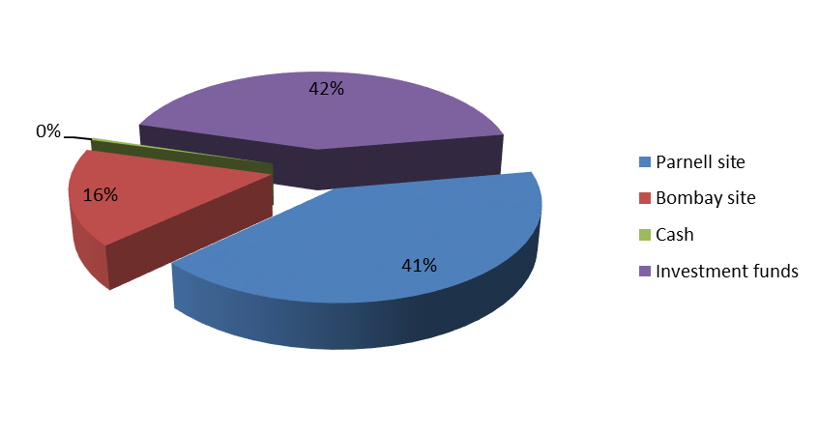

As can be seen,the value of the Bombay and Parnell properties continue to represent a very significant component of the Trust’s total capital. Trustees remain aware that the properties produce almost no income for the Trust, and that the future of these properties will be dependent on the finalisation of the Trust’s long-term strategy.

**LIAISON WITH STAKEHOLDERS**

The Trust remains in close liaison with the Anglican Church of Aotearoa, New Zealand and Polynesia to which the Trust reports and by whom Trustees are appointed. Meetings of Alumni groups are also attended by Trustees as frequently as possible, especially as the Trust progresses its research into the establishment of a kura in liaison with these stakeholders..

**TRUSTEES**

As of 30 September 2018 the Trustees were:

Appointed

Or reappointed

* Pihopa Te Kitohi Pikaahu (Chair) May 2016
* Keringawai Evans May 2014
* Karleen Everitt June 2018
* Selwyn Parata May 2016
* Agnes Naera Feb 2018
* Tama Potaka April 2018
* Bernard Te Paa May 2018

At its December 2019 Annual General Meeting, Mr Bernard Te Paa, having serviced the maximum term as Chair per the Trust’s Constitution, stood down from this office. Consequently the Rt Rev. Kito Pikaahu was appointed Chair by Trustees.

The Trust presently has a vacancy, its maximum number of trustees being limited to eight. Additionally, in accordance with the Constitution of the Trust, the two longest serving Trustees must offer their retirements at commencement of the meeting of the Church’s General Synod / Te Hīnota Whānui in May 2018.

The two longest serving Trustees at this time are Keringawai Evans and Selwyn Parata who thereby offer their resignation to Synod.

**THANKS**

The Trust continued to maintain a very close relationship with its Manager, Trust Investments Management Limited and the performance of the Trust is good evidence of the strength and collegiality of this relationship.

I also wish acknowledge the commitment and passion my fellow trustees in regard to our strategic deliberations and dealing with the challenges that face the Trust and for their support in my role as Chairman.

**CLOSING**

The Trust Board remains passionate and committed to its role as steward of the St Stephen’s and Queen Victoria Schools Trust and looks forward to refining and implementing its strategy to achieve its principal purpose to provide the sustainable delivery of education resources primarily to Maori, all to the glory of God.

Rt. Rev Kito Pikaahu January 2019

Heamana